**­­­**

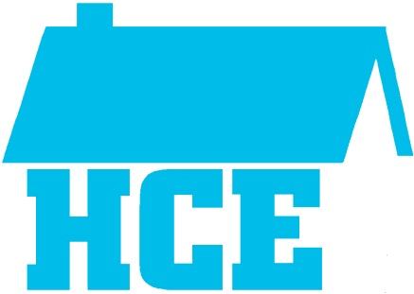

**Wisconsin Association for  
Home & Community Education**

­­­­

­­

Volunteers Build Capacity  
  
WAHCE State Conference  
Programs, Opportunities & Leadership (P.O.O.L.)  
September 2012

Kandi O’Neil, Associate State 4-H Program Director/  
Volunteer Specialist  
University of Wisconsin-Cooperative Extension  
[kandi.oneil@ces.uwex.edu](mailto:kandi.oneil@ces.uwex.edu)  
608-262-2050

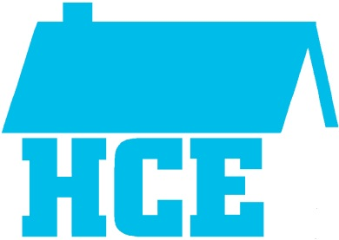**­­­**

­­­­

­­

**Wisconsin Association for  
Home & Community Education**

Volunteers Build Capacity  
  
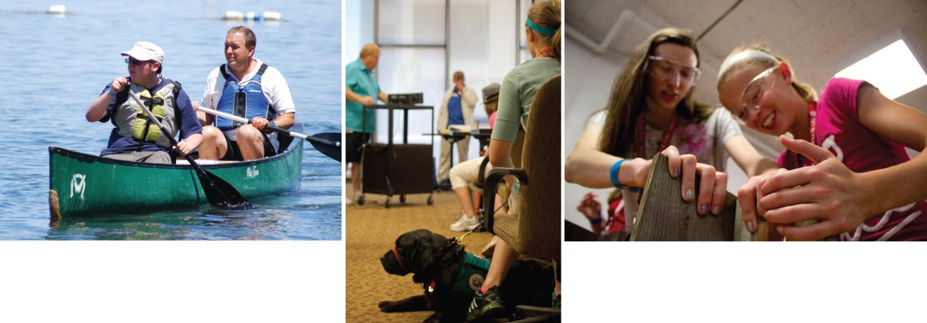

WAHCE State Conference  
Programs, Opportunities & Leadership (P.O.O.L.)  
September 2012

Kandi O’Neil, Associate State 4-H Program Director/  
Volunteer Specialist  
University of Wisconsin-Cooperative Extension  
[kandi.oneil@ces.uwex.edu](mailto:kandi.oneil@ces.uwex.edu)  
608-262-2050